**Project Design Phase-II**

**Data Flow Diagram &User Stories**

|  |  |
| --- | --- |
| Date | 31 October 2022 |
| Team ID | PNT2022TMID40687 |
| Project Name | Project - Exploratory Analysis of Rainfall Data in India for Agriculture |
| Maximum Marks | 4 Marks |

**Data Flow Diagrams:**

A Data Flow Diagram (DFD) is a traditional visual representation of the information flows within a system. A neat and clear DFD can depict the right amount of the system requirement graphically. It shows how data enters and leaves the system, what changes the information, and where data is stored.

**`** 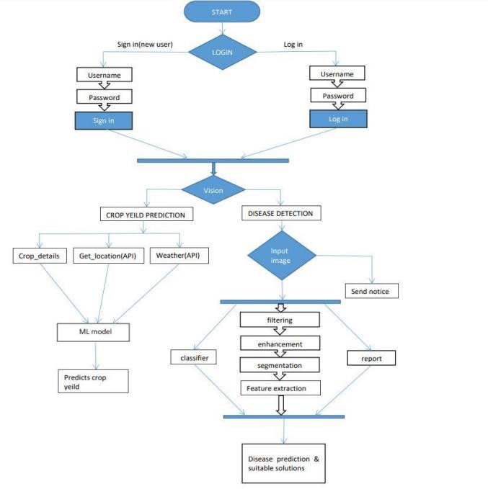

**User Stories**

Use the below template to list all the user stories for the product.

|  |  |  |  |  |  |  |
| --- | --- | --- | --- | --- | --- | --- |
| **User Type** | **Functional**  **Requirement**  **(Epic)** | **User Story Number** | **User Story / Task** | **Acceptance criteria** | **Priority** | **Release** |
| Customer  (Mobile user) | Registration | USN-1 | As a user, I can register for the application by entering my email, password, and confirming my password. | I can access my account / dashboard | High | Sprint-1 |
|  |  | USN-2 | As a user, I will receive confirmation email once I have registered for the application | I can receive confirmation email & click confirm | High | Sprint-1 |
|  |  | USN-3 | As a user, I can register for the application through Facebook | I can register & access the dashboard with Facebook  Login | Low | Sprint-2 |
|  |  | USN-4 | As a user, I can register for the application through Gmail |  | Medium | Sprint-1 |
|  | Login | USN-5 | As a user, I can log into the application by entering email & password |  | High | Sprint-1 |
|  | Dashboard | USN-6 | As a user , I can view the details about the page and navigate through the entire pages | I can navigate through the pages. | Medium | Sprint-1 |
|  | Prediction | USN-7 | User can search for the area / place where the user wants to know the prediction of rainfall . | Searching for the region within INDIA only be  accepted | High | Sprint-1 |
|  |  | USN-8 | The prediction or analysis for the desired region for the future or past events respectively |  | High | Sprint-1 |
|  |  | USN-9 | User can see the visualization of the rainfall data for the specific region in INDIA for a specified time period. |  | High | Sprint-1 |
|  | News | USN-10 | User can view the latest news articles related to agriculture. | I can view the news articles. | Medium | Sprint-2 |
| Customer (Web user) | Support | USN-11 | User can ask queries about the system. | I can rectify my doubts | High | Sprint-3 |
| Customer Care Executive |  | USN-12 | The team must analyse all the queries and debug it in the next update |  | High | Sprint-3 |
| **User Type** | **Functional**  **Requirement**  **(Epic)** | **User Story Number** | **User Story / Task** | **Acceptance criteria** | **Priority** | **Release** |
| Core development team | Core function | USN - 14 | Design and develop the application in such a way that the best user interface and maintenance should be taken care of |  | High | Sprint-1 |
|  |  | USN - 1 5. | The website is responsive on all the devices and the screen sizes. User experience should be good irrespective of the devices or platforms |  | High | Sprint - 1 |